12025 Supporting Information
Online appendix: Supporting Information (SI)

“Fighting the Youth: Youth Bulges and State Repression”,
Ragnhild Nordås & Christian Davenport
Corresponding author: Ragnhild@prio.no

Histograms for main dependent variables
The histograms below show the distribution of the Political Terror Scale based on US State Department Reports PTS(S) and Political Terror Scale based on Amnesty International reports PTS(A) in the sample of the article. Both show a distribution that approaches a normal distribution.
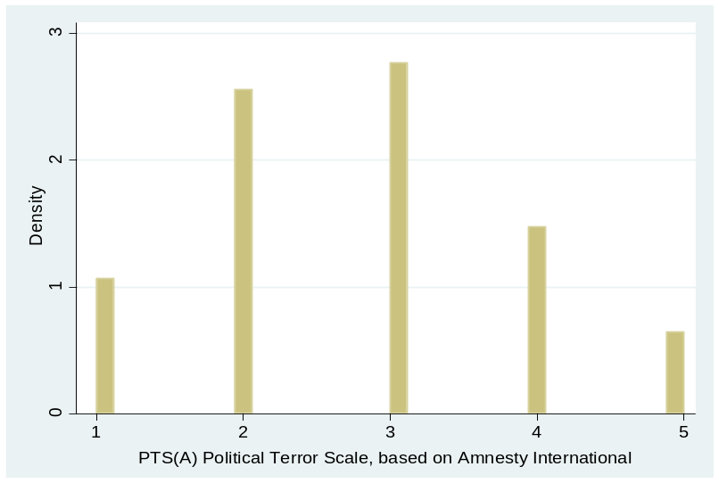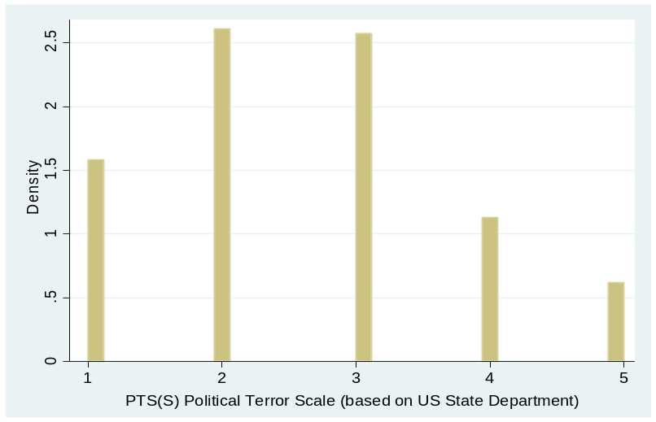
SI Figure 1. Histograms of main dependent variables in analyses

Descriptive statistics
Below, Table SI 1 report the descriptive statistics for all variables used in the article.
Variable | N | Mean | Std. Dev. | Min | Max
PTS(A) | 3,148 | 2.754 | 1.110 | 1 | 5
PTS(S) | 3,827 | 2.312 | 1.173 | 1 | 5
Youth bulge | 4,014 | 29.922 | 7.027 | 12.9 | 45
Youth bulge (to total pop.) | 4,014 | 18.456 | 2.465 | 10.9 | 25.4
Dissent | 3,539 | 1.257 | 3.464 | 0 | 49
Dissent*Youth bulge | 3,486 | 8.720 | 13.883 | 0 | 40.6
Democracy, tricotomy | 4,123 | 0.437 | 0.759 | 0 | 2
Democracy *Youth bulge | 4,014 | 6.720 | 11.427 | 0 | 39.9
Civil conflict | 4,590 | 0.160 | 0.367 | 0 | 1
GDP per capita, ln | 4,123 | 8.314 | 1.041 | 5.620 | 10.738
Population, ln | 4,123 | 8.663 | 1.874 | 4.060 | 14.060

Correlation matrix
Below is the correlation matrix for the main variables used in the tables in the article. The two dependent variables are quite highly correlated, as are the two measures of youth bulges (measured as 15-24 years olds to the total adult population or measured against the total population, respectively), which is to be expected.
 | PTS(A) | PTS(S) | Youth bulge | Youth bulge (tp) | Dissent | Demo-cracy | Civil conflict | GDP per cap., ln
PTS(A) | 1.0000
PTS(S) | 0.7898 | 1.0000
Youth bulge | 0.4268 | 0.4177 | 1.0000
Youth bulge (tot. pop.) | 0.4148 | 0.3961 | 0.8709 | 1.0000
Dissent | 0.1203 | 0.0831 | -0.0471 | 0.0432 | 1.0000
Democracy tricotomy | -0.4363 | -0.4684 | -0.5771 | -0.4555 | 0.0373 | 1.0000
Civil conflict | 0.5373 | 0.5465 | 0.2083 | 0.1814 | 0.1116 | -0.1189 | 1.0000
GDP per capita, ln | -0.3694 | -0.4344 | -0.7154 | -0.4967 | 0.0577 | 0.5654 | -0.2379 | 1.0000
Population, ln | 0.2452 | 0.2154 | -0.0772 | 0.0311 | 0.2941 | 0.0841 | 0.2400 | -0.0072

The other correlations are mostly not very high. One exception is the correlation between GDP per capita and the measure of youth bulges relative to the adult population, which is at 0.7154. This could suggest that there is some effect of GDP per capita on demography, whereby youth bulges are in part a product of the development levels in a country. Although this is outside the focus of the article, the source of youth bulges is a potential future research area which could add insights into the demography-repression nexus. Interestingly, as well, is the fact that the measure of youth bulges to the total population is not very highly correlated with GDP per capita (0.4967), which suggests that it is those countries with a very high child population that are associated with lower GDP, which again is not surprising- the least developed countries often have elevated fertility rates, but many children in these societies do not survive early childhood due to high infant mortality.

Models with Alternative Control Variables
Additional controls or alternative specifications are introduced to some models for robustness checks. These are not included in the models in the main article for reasons of parsimony, because they are less established in the literature, or because they restrict our sample.
As a robustness test, we ran Model 1 (from Table 1) using different control variables than the ones reported in the article. Supporting Information Table 1 (below) shows results with the first three alternative controls. All models show that the main finding of the relationship between youth bulges and state repression remains robust with these controls included:
First, as an alternative measure of development we use a measure of Infant Mortality Rate (IMR), as was done by Urdal (2006). Infant mortality has been used as an alternative to GDP per capita or similar measures in quantitative studies in the conflict literature and elsewhere (Urdal 2006; Achvarina et al. 2009). The two are very highly correlated typically (in our sample the correlation is -0.7583) and believed to capture the same phenomenon of general development. IMR is closer to being a poverty measure than GDP per capita, which is sometimes seen as a proxy for state capacity, and might be a preferred measure of development to capture variations among poorer countries.
We also run a model with the Polity scale for -10 (full autocracy) to 10 (full democracy) as an alternative measure of regime type, as this was previously the most commonly used democracy measure in repression models (e.g., Davenport 1999; Hafner-Burton 2005; Saideman et al. 2002). The data is from the Polity IV dataset (Marshall and Jaggers 2003). As alternative and additional measure of conflict, we also include a dummy for ongoing international war (from UCDP/PRIO dataset) in one model (Gleditsch et al. 2002). Although arguments have been made about international wars increasing the probability that we will see repression (Poe et al. 1999), the empirical evidence here is mixed (Richards et al. 2001; Landman, 2005). Last, we include a dummy for the Cold War period as was done by Wood (2008). This variable helps control for difference in the measures of the dependent variables over time, as the two sources of information on state repression have been found to be biased particularly during the Cold War period (Poe, Vasquez, and Carey 2001). Cold War is a dummy variable coded 1 for all years prior to 1991.

Supporting Information Table 1. Alternative controls: IMR, Polity scale, International war, and Cold War
 | w/IMR  (Urdal 2006) | w/Polity scale -10/+10  (Marshall & Jaggers 2005) | w/International war dummy  (Gleditsch et al. 2002) | w/Cold war dummy
Youth bulge | 0.029*** | 0.036*** | 0.027*** | 0.028***
 | (0.006) | (0.006) | (0.006) | (0.006)
Polity 8-9 (dummy) | -0.212** |  | -0.182** | -0.212**
 | (0.087) |  | (0.084) | (0.086)
Polity 10 (dummy) | -0.953*** |  | -0.904*** | -0.960***
 | (0.136) |  | (0.140) | (0.139)
Civil conflict | 0.789*** | 0.766*** | 0.833*** | 0.778***
 | (0.083) | (0.087) | (0.081) | (0.080)
Dissent | 0.013* | 0.018** | 0.016** | 0.013*
 | (0.007) | (0.007) | (0.008) | (0.007)
Population, ln | 0.079*** | 0.076*** | 0.090*** | 0.084***
 | (0.022) | (0.022) | (0.023) | (0.022)
GDP per capita, ln |  | 0.014 | 0.021 | 0.042
 |  | (0.041) | (0.045) | (0.043)
IMR | -0.001
 | (0.001)
Polity scale |  | -0.018***
 |  | (0.005)
International war |  |  | 0.239
 |  |  | (0.203)
Cold War |  |  |  | -1.414***
 |  |  |  | (0.161)
LDV=2 | 1.228*** | 1.426*** | 1.330*** | 1.228***
 | (0.163) | (0.168) | (0.188) | (0.163)
LDV=3 | 2.283*** | 2.536*** | 2.399*** | 2.287***
 | (0.190) | (0.189) | (0.218) | (0.190)
LDV=4 | 3.332*** | 3.574*** | 3.448*** | 3.334***
 | (0.204) | (0.201) | (0.233) | (0.204)
LDV=5 | 4.449*** | 4.695*** | 4.489*** | 4.449***
 | (0.226) | (0.224) | (0.249) | (0.225)
Pseudo R² | .387 | .379 | .395 | .387
N | 2,586 | 2,586 | 2,275 | 2,586
Robust standard errors in parentheses. Models run with year dummies (not reported).
*** p<0.01, ** p<0.05, * p<0.1

More additional variables are included in some models based on Model 1 in Table 1 in the article. We enter a dummy variable that takes the value 1 if oil exports are greater than 1/3 of GDP and 0 if not, taken from Fearon and Laitin’s (2003) replication dataset, as this was found to be an important predictor of repression in a study of assessing Islam’s effects on repression (de Soysa and Nordås 2007). Resource wealth can raise the stakes for state capture and lower the incentive of rulers to reform (Jensen and Wantchekon 2004; Acemoglu and Robinson 2006). We expect, therefore, that states that are resource wealthy, such as oil-rich ones, will be more willing to resort to human rights violations than those that are not (de Soysa and Binningsbø 2005). As Muslim countries have been argued to be more repressive, we also control for religion by measures of the relative size of the Protestant, Catholic, and Muslim, using measures from de Soysa and Nordås (2007). Wood (2008) finds sanctions and trade to matter for state repression. We also include his measures of trade (lagged) and sanctions (binary indicator of all sanction events) as a robustness test.

Supporting Information Table 2. Alternative Controls 2: Oil, Religion, Trade, and Sanctions
DV: PTS(A) | w/Oil dummy  (Fearon & Laitin 2003) | w/Religion shares  (de Soysa & Nordås 2007) | w/Trade  (Wood 2008) | w/Sanctions  (Wood 2008)
Youth bulge | 0.025*** | 0.026*** | 0.028*** | 0.028***
 | (0.006) | (0.007) | (0.006) | (0.006)
Polity 8-9 (dummy) | -0.176** | -0.204*** | -0.213** | -0.185**
 | (0.082) | (0.079) | (0.086) | (0.092)
Polity 10 (dummy) | -0.866*** | -0.898*** | -0.948*** | -0.915***
 | (0.140) | (0.154) | (0.139) | (0.145)
Civil conflict | 0.832*** | 0.836*** | 0.777*** | 0.776***
 | (0.082) | (0.078) | (0.081) | (0.085)
Dissent | 0.018** | 0.016** | 0.013* | 0.010
 | (0.008) | (0.008) | (0.007) | (0.007)
GDP per capita, ln | 0.001 | 0.012 | 0.080 | 0.028
 | (0.046) | (0.047) | (0.065) | (0.042)
Population, ln | 0.094*** | 0.096*** | 0.112*** | 0.082***
 | (0.024) | (0.025) | (0.036) | (0.022)
Oil 1/3 of GDP | 0.178**
 | (0.075)
Share pop. Muslim |  | 0.001
 |  | (0.001)
Share pop. Catholic |  | 0.002
 |  | (0.001)
Share pop. Protestant |  | -0.000
 |  | (0.002)
Trade (lag) |  |  | -0.031
 |  |  | (0.033)
Sanctions (lag) |  |  |  | 0.241***
 |  |  |  | (0.064)
LDV=2 | 1.329*** | 1.307*** | 1.228*** | 1.237***
 | (0.191) | (0.190) | (0.163) | (0.164)
LDV=3 | 2.375*** | 2.358*** | 2.280*** | 2.273***
 | (0.220) | (0.220) | (0.190) | (0.190)
LDV=4 | 3.431*** | 3.395*** | 3.321*** | 3.284***
 | (0.235) | (0.238) | (0.205) | (0.206)
LDV=5 | 4.457*** | 4.421*** | 4.435*** | 4.373***
 | (0.251) | (0.257) | (0.224) | (0.228)
Pseudo R² | .394 | .392 | .388 | .390
N | 2,253 | 2,230 | 2,573 | 2,585
Robust standard errors in parentheses. All models run with year dummies (not reported).
*** p<0.01, ** p<0.05, * p<0.1

Supporting Information Table 2 (above) shows results with these alternative controls. Youth bulges remain significant and positively related to state repression in all models. Out of the added controls, oil is statistically significant (at the 5% level) and in the expected direction, and there is a significant positive relationship (at the 1% level) between sanctions and repression, in line with findings by Wood (2008). The other variables in the models perform akin to in the original Model 1.

Alternative Models with CIRI as Dependent Variable
Below, we provide models using the Cingranelli & Richards (2004) measure of human rights violations – infringements on physical integrity rights, as an alternative measure of state repression. The findings are the same as those found when using the Political Terror Scale (PTS) measures: Youth bulges are associated with a higher level of state repression of physical integrity rights of its citizens; and the effect is linear – showing no indication of a threshold effect.

Supporting Information Table 3. Youth Bulges and State Repression, 1976-2000. Dependent Variable: Cingranelli and Richards (2004) Infringements on Physical Integrity Rights Scale (0-8)
 | Youth Bulges and State Repression, 1976-2000 | Non-linear/ threshold effects of youth bulges, 1976-2000
Youth bulge | 0.022*** | 0.018***
^{15-24 y.o. / adult pop.} | (0.006) | (0.007)
Youth bulge, squared |  | -0.001
 |  | (0.001)
Polity= 8/9 | -0.223*** | -0.236***
 | (0.074) | (0.075)
Polity=10 | -0.925*** | -0.895***
 | (0.119) | (0.116)
Ln(Population) | 0.124*** | 0.127***
 | (0.020) | (0.020)
Ln(GDP/cap) | -0.026 | -0.028
 | (0.042) | (0.042)
Civil conflict | 0.783*** | 0.774***
 | (0.069) | (0.068)
Dissent | 0.017** | 0.016**
 | (0.008) | (0.008)
LDV Repression _{t-1} | 0.502*** | 0.501***
 | (0.022) | (0.022)
Pseudo R² | 0.313 | .314
Countries | 147 | 147
N | 2,448 | 2,448
Robust standard errors in parentheses, Huber-White clustering on country.
All models with year dummies (not reported).
*** p<0.01, ** p<0.05, * p<0.1

References, Supporting Information
Acemoglu, Daron, and James A. Robinson. 2006. “Economic Backwardness in Political Perspective.” American Political Science Review 100 (1): 115–31.
Achvarina, Vera; Ragnhild Nordås, Gudrun Østby and Siri Aas Rustad. 2009. “Armut und die Rekrutierung von Kindersoldaten: Eine disaggregierte Studie der afrikanischen Regionen.” [“Regional Poverty and Child Soldier Recruitment: A Disaggregated Study of African Regions”]. Politische Vierteljahresschrift. Special Issue (43).
Cingranelli, David L., and David L. Richards. 2004. “The Cingranelli-Richards (CIRI) Human Rights Dataset 1980–2004.” http://www.humanrightsdata.com.
Davenport, Christian. 1999. “Human Rights and the Democratic Proposition.” Journal of Conflict Resolution 43: 92-116.
de Soysa, Indra and Helga Malmin Binningsbø. 2005. “The Devil's Excrement as Social Cement: Natural Resources and Political Terror, 1980–2002.” International Social Science Journal 57: 21–32.
de Soysa, Indra and Ragnhild Nordås. 2007. ”Islam’s Bloody Innards? Religion and Political Terror, 1980–2000.” International Studies Quarterly 51(4): 927–943.
Fearon, James D. and David Laitin. 2003. “Ethnicity, Insurgency, and Civil War.” American Political Science Review 97(1): 75–90.
Gleditsch, Nils Petter, Peter Wallensteen, Mikael Eriksson, Margareta Sollenberg, and Håvard Strand. 2002. ”Armed Conflict 1946–2001: A New Dataset.” Journal of Peace Research 39 (5):615–37.
Hafner-Burton Emilie. 2005. Trading Human Rights: How Preferential Trade Agreements Influence Government Repression. International Organization 59(Summer): 593–629.
Jensen, Nathan and Leonard Wantchekon. 2004. “Resource Wealth and Political Regimes in Africa.” Comparative Political Studies 37 (7): 816–41.
Landman, Todd. 2005. Protecting Human Rights: A Comparative Study. Washington, DC: Georgetown University Press.
Marshall, Monty, and Keith Jaggers. 2005. "Polity IV Project: Political Regime Characteristics and Transitions, 1800-2004. Data Users' Manual." Available at http://www.cidcm.umd.edu/polity/data/p4manualv2004.pdf.
Poe, Steven, Tanya Vasquez, and Sabine Carey. 2001. ‘‘How Are These Pictures Different: Assessing the Biases in the U.S. State Department’s Country Reports on Human Rights Practices.’’ Human Rights Quarterly 23 (3): 650–677.
Poe, Steven C., Neal Tate, and Linda C. Keith. 1999. “Repression of the Human Rights to Personal Integrity Revisited: A Global Cross-National Study Covering the Years 1976-1993.” International Studies Quarterly 43: 291-313.
Richards, David, Ronald Gelleny and David Sacko. 2001. “Money With a Mean Streak? Foreign Economic Penetration and Government Respect for Human Rights in Developing Countries.” International Studies Quarterly 45(2):219–39.
Saideman, Stephen M.; David J. Lanoue, Michael Campenni, and Samuel Stanton. 2002. “Democratization, Political Institutions, and Ethnic Conflict: A Pooled Time-Series Analysis, 1985-1998.” Comparative Political Studies 35: 103-129.
Urdal, Henrik. 2006. “A Clash of Generations? Youth Bulges and Political Violence.” International Studies Quarterly 50: 607-629.
Wood, Reed M. 2008. “’A Hand upon the Throat of the Nation’: Economic sanctions and State Repression, 1976-2001.” International Studies Quarterly 52: 489-513.

